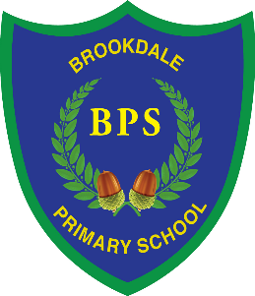
7th April 2022

Dear Parents,

Following the diagnosis of a severe nut allergy for one of our pupils, I am writing to inform you that, as of next term (25th April 2022), Brookdale will be a nut free school.

Children who suffer from nut allergies can develop a severe, potentially life-threatening allergic reaction. If someone has a nut allergy, it is not just eating nuts that can cause a severe reaction: just being touched on the skin or smelling the breath of someone who has had nuts, or a product containing nuts, can trigger anaphylactic shock which can cause breathing and swallowing difficulties.

Our school kitchen is already nut free and first aid staff in the school are trained to use auto injectors which are required immediately if an allergic reaction occurs however, as I am sure you will understand, we would prefer to avoid this if at all possible.

As of next term, I would be grateful if you could ensure that no nuts or nut-based products are brought into school in lunch boxes or as a snack. For example:
- Peanut butter
- Chocolate spreads
- Some cereal bars
- Some granola bars
- Cakes that contain nuts
- Biscuits / Cookies that contain nuts
- Sauces that contain nuts (e.g. satay)

This list is not exhaustive, please check the packaging of products carefully. To be clear, this rule applies only to items that list nuts as an ingredient and NOT those that suggest they ‘may contain traces of nuts’ or ‘may have been prepared in a factory containing nuts’. Our Health and Safety Consultants have confirmed that these are the reasonably practicable measures we can take to keep all of our pupils safe at school. The school also has emergency medication to administer should the need arise.

I appreciate that this is an additional thing to check each day but am sure you will appreciate the importance of avoiding a potentially life-threatening situation for one of our pupils and would expect the same consideration of others if your child were to have a similar condition.

Should you have any questions, please do not hesitate to contact me.

Yours sincerely,
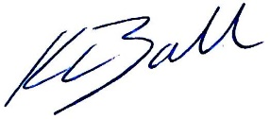

Kate Ball
Headteacher

