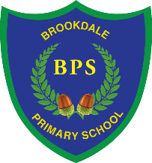
Brookdale Early Years
Fees 2023-2024
Hours per week | Fees*
0.5 hour | £3
1 hour | £6
2 hours | £12
2.5 hours | £15
3 hours | £18
3.5 hours | £21
4 hours | £24
4.5 hours | £27
5 hours | £28
1 full day | £30

* Fees will be charged for any hours over and above 15 hours funded or 30 hours funded as appropriate and for those not in receipt of funding.

Fees are payable in advance at the beginning of each half term. Fees should be paid online via ParentPay. Parents will be given individual login details.

