Brookdale Primary School
Early Years
Prospectus
2023

Contact: Mrs Kate Ball (Headteacher)
Brookdale Primary School
Escolme Drive
Greasby
Wirral
CH49 1SE

0151 677 5170

schooloffice@brookdale.wirral.sch.uk
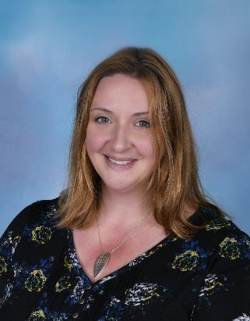
October 2023

Dear Parents/Carers,

Thank you for your enquiry regarding Brookdale Early Years.
We hope that this prospectus will provide you with all the information you need.
To make an appointment to view our setting, please telephone the school office and we will be delighted to arrange this for you. This would also be an ideal time for us to discuss your child-care needs and any suitable vacancies.
We look forward to meeting you soon.

Best wishes

Miss Kate Ball
Headteacher

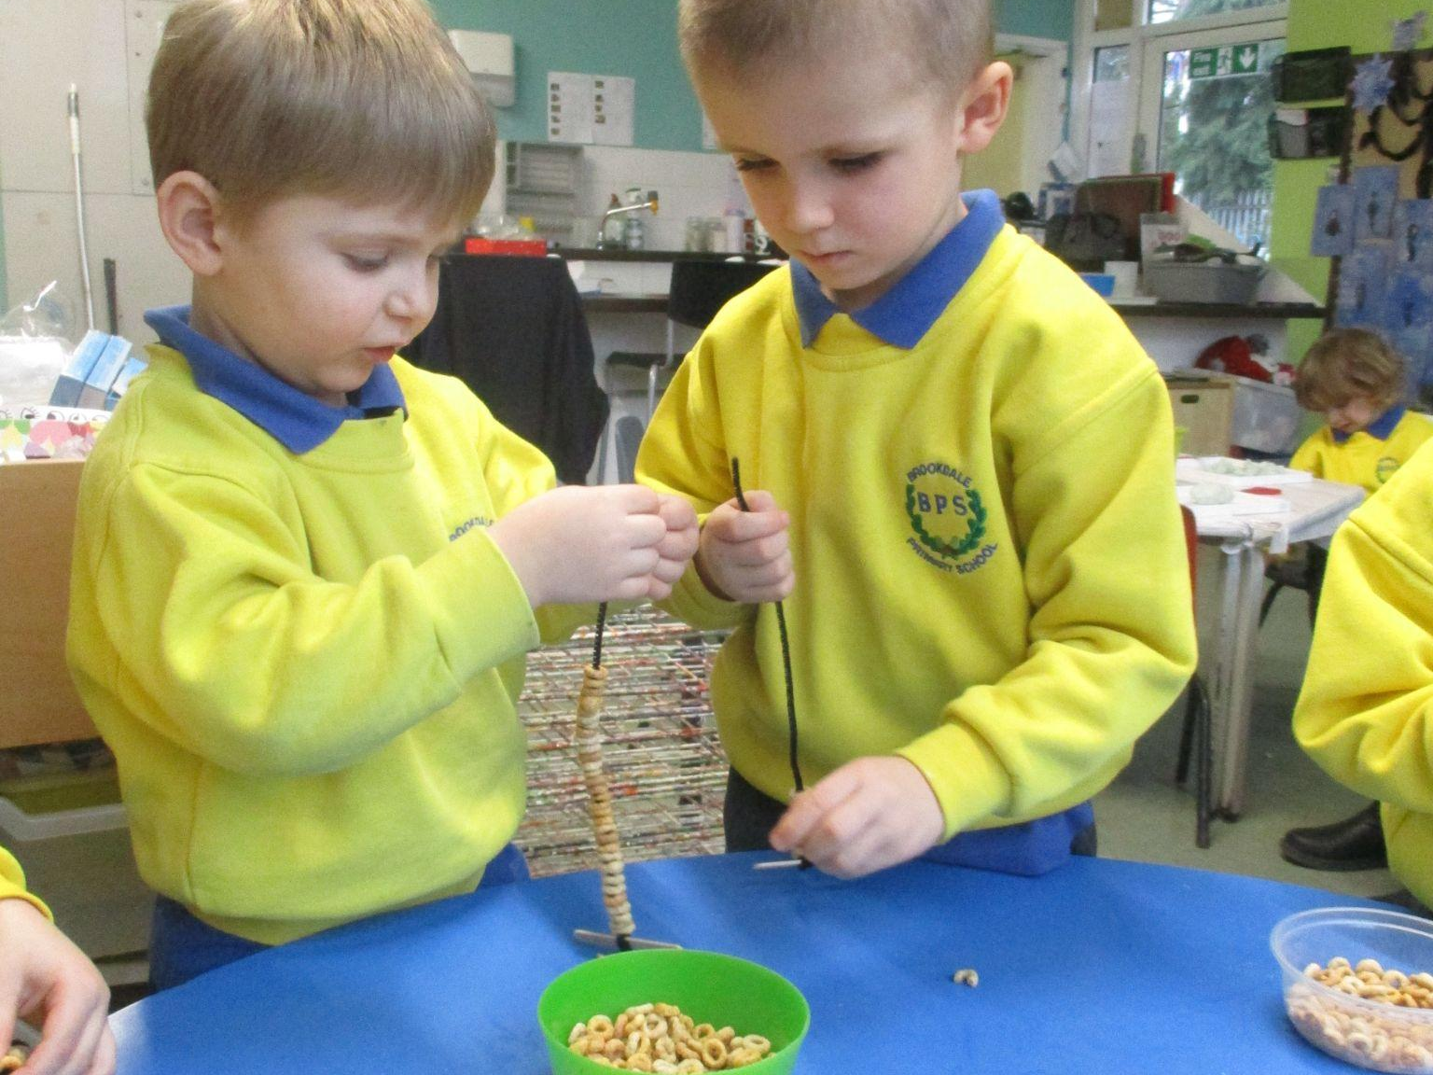
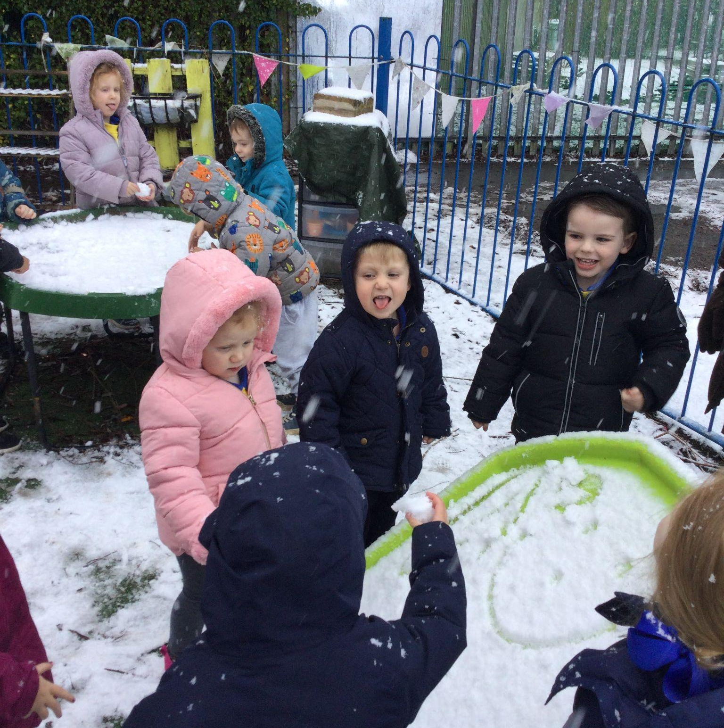

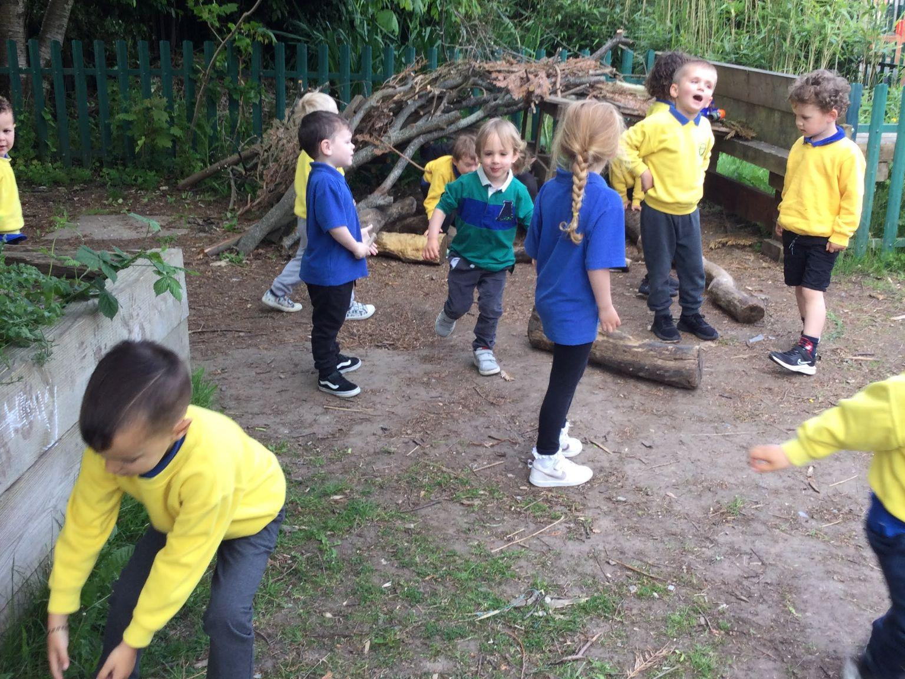
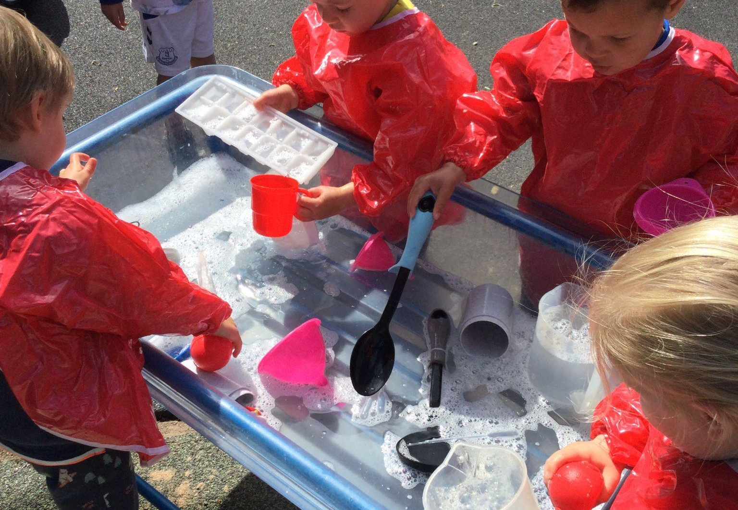

Introduction

Brookdale Early Years is a setting led by the governors and leadership team of Brookdale Primary School. The setting was initially established in 1997 as a separate organisation within Brookdale Primary School and made the decision to merge with the main school in September 2022. The setting’s most recent Ofsted inspection report judged us as ‘good’.

The preschool is open 38 weeks of the year, term time only, from 8.50am until 3.20pm, and offers both sessional and full day care.

We are based in 2 classrooms, with our own outdoor area, and the additional use of the facilities within the main school. We have strong links and work very closely with the staff and children in the main school.

*Please note, as with all other settings, a place in Brookdale Early Years does NOT guarantee a place in the main school when your child reaches school age. Parents must apply through the usual admissions process via: https://www.wirral.gov.uk/primary-education-information-parents

Staff
All staff are subject to Enhanced DBS checks. Our staff currently consists of:

Name | Position | qualifications | Years experience
Mrs R Doig | Early Years Leader | NNEB, NVQ 4, BA Honours (Childcare studies) Early Years Professional Status  MA Early Childhood | 30 years +
Mrs T Smith | Teaching Assistant | NVQ 3, BA Honours( Early Years Leadership and Management) | 25 years
Mrs C Lloyd | Teaching Assistant | NVQ 3 | 16 years
Mr I Knapton | Teaching Assistant | NVQ 3 | 17 years

Our Child:Staff ratios are:
Under 3’s – 1:4
Over 3’s – 1:8

All staff regularly attend training to further support their professional development, and all staff have a current Paediatric First Aid certificate and Safeguarding/Child Protection training.

Safeguarding
Our Designated Safeguarding Lead is Miss Kate Ball (Headteacher) with Mrs Doig, Mrs Knapton, Mrs Neal and Mr Knapton as qualified Deputy DSL’s in place in case of her absence.
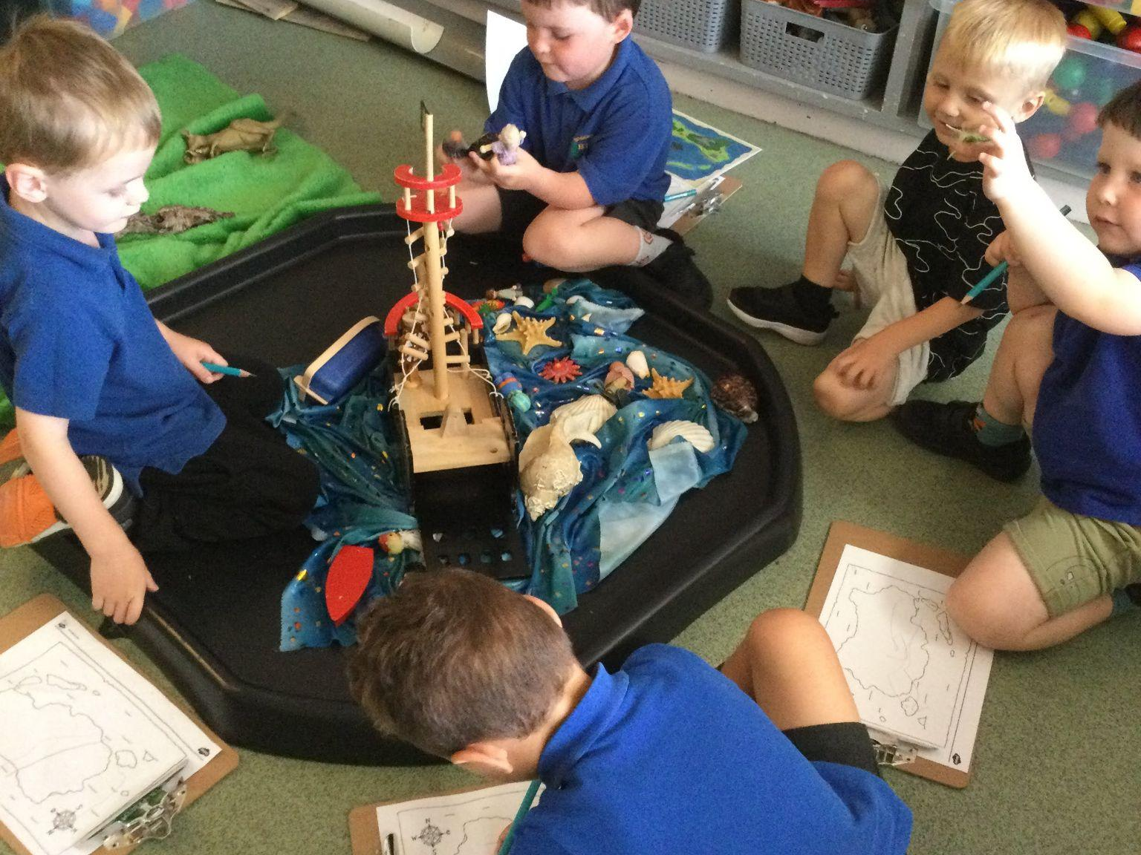

Our Ethos

- Our ethos is to provide high quality, safe and inclusive child care that has regard for the themes and commitments of the Early Years Foundation Stage Framework.
- We have a commitment to building positive relationships while working in partnership with parents/carers and working closely with other agencies to ensure that the children in our care are receiving the best possible start to their education.
- Our expectation is that we will provide an enabling environment, both inside and out, that offers a wide variety of experiences and activities that will help all children to develop to their full potential during their time with us.
- In order to help us monitor the success of these experiences and activities, and their part in child development, we observe the children ‘at play’ and use these observations to help us make informed decisions in our planning to cater for the individual needs of the children. We view each child as unique.
- In order to ensure the children’s learning and development needs are met we plan using the principles of The Early Years Foundation Stage and ensure that all planning is flexible and allows for spontaneity and for the ideas of the children to be explored as these are paramount in their continued all round development.

Our Values
These values are promoted in everything we do

- Respect
- Determination
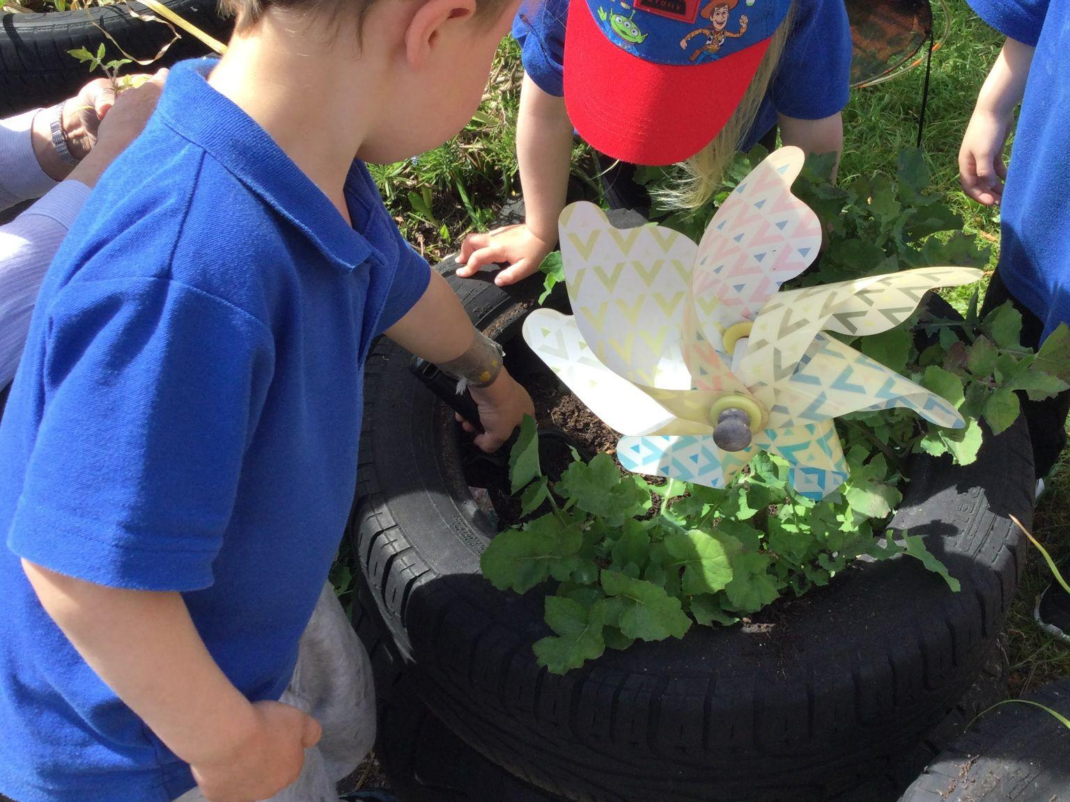
- Teamwork
- Friendship
- Responsibility
- Compassion.

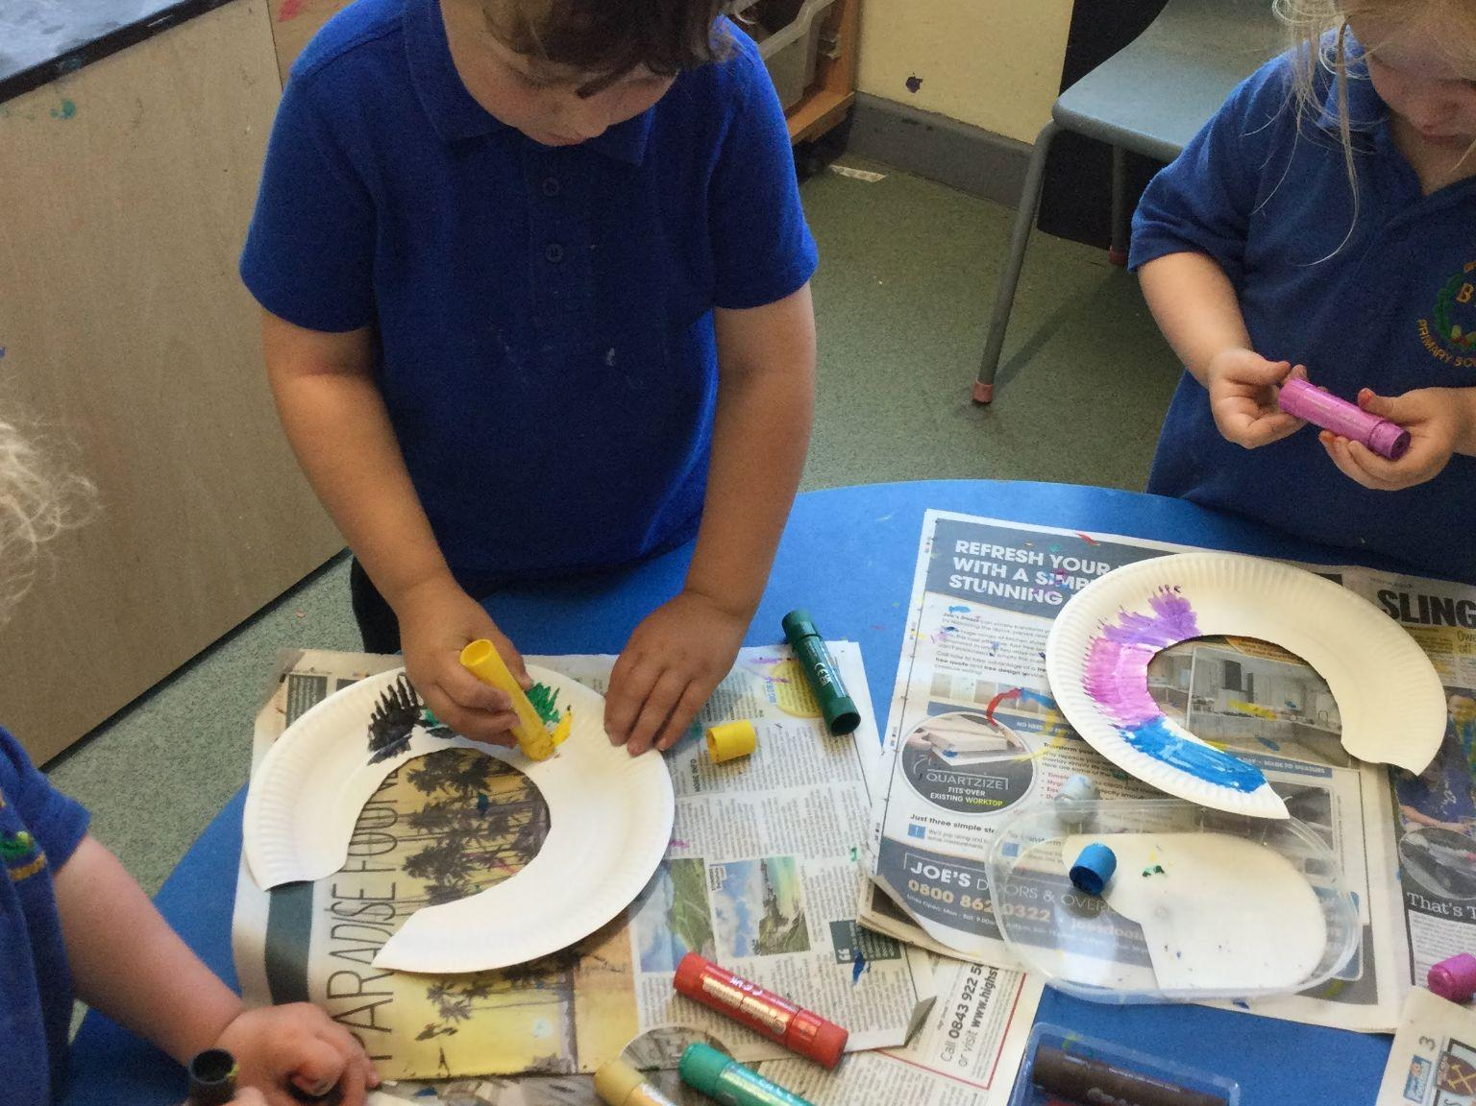

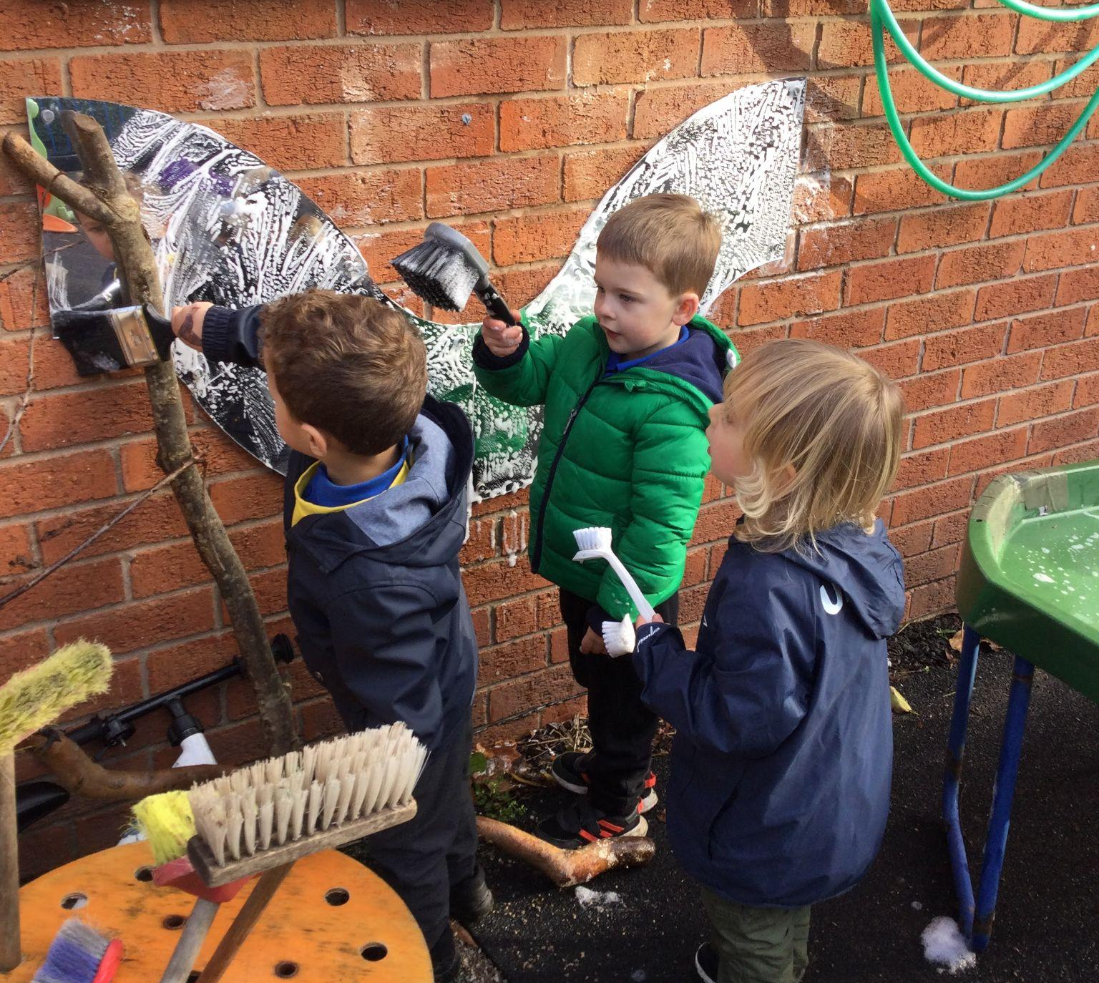

Opening Times

Full day care: 8.45am to 3.15pm

Morning sessions: 8.45am to 11.45am
Afternoon sessions: 12.45pm to 3.15pm

Lunch 11.45am to 12.45pm

We currently cater for @ 24 children per session but can take more subject to ratios.

Before and after school facilities are available within the main school. If you require any information, please contact Acorns 07519810189 / 01516775170

Fees

The Early Years Funding is available to all children the term after their 3rd birthday. All children are entitled to up to 15 hours childcare. Any hours above the 15 funded will be charged at our current rate unless you qualify for the Extended Early Years Funding Entitlement. This gives you an additional 15 hours of childcare.
Please se separate sheet explaining additional costs regarding funding and payment options.

Parents can sign up for Tax Free Childcare. If you are eligible, you need to sign up to set up an online account, using our registration number – 105028 – to make payment via Parent Pay.

More information is available on www.childcarechoices.gov.uk

We also accept a number of workplace childcare vouchers including Fideliti, Busy Bees, and Sodexo.

We are also registered for 2-year-old funding. For further information on this please contact your Health Visitor or visit:
https://www.gov.uk/help-with-childcare-costs/free-childcare-2-year-olds

Rising 4s are given priority for morning sessions and full days. For under 3s these will be allocated if sessions are available after the allocation date at the beginning of April.

Fees are payable regardless if your child is absent due to illness or holidays.
Fees are to be paid ½ termly, in advance (weekly payments may be made by special arrangement). Fees should be paid via Parent Pay.
Fees are subject to review and may be increased with at least 4 weeks’ notice.

Notice of Withdrawal – A minimum of 4 weeks’ notice must be given, in writing when terminating a place at the preschool. Full fees will be charged during this period.
The Session

We organise our sessions so that children can choose from, and work at, a range of activities to build up their ability to select and work through a task to its completion. We work under the philosophy of continuous provision, offering the children areas of provision which include small world, mark-making, creative area, construction, role play etc. We work within the Early Years Foundation Stage Framework, ensuring the children develop their full potential within the 7 areas of development. During each session, children will be involved in physical activities including yoga.

Child initiated play and learning is encouraged but we will also involve the children in adult-directed activities after careful observation and assessment of each child’s needs. This will enable them to enhance their learning and development of new skills and offer them challenges.
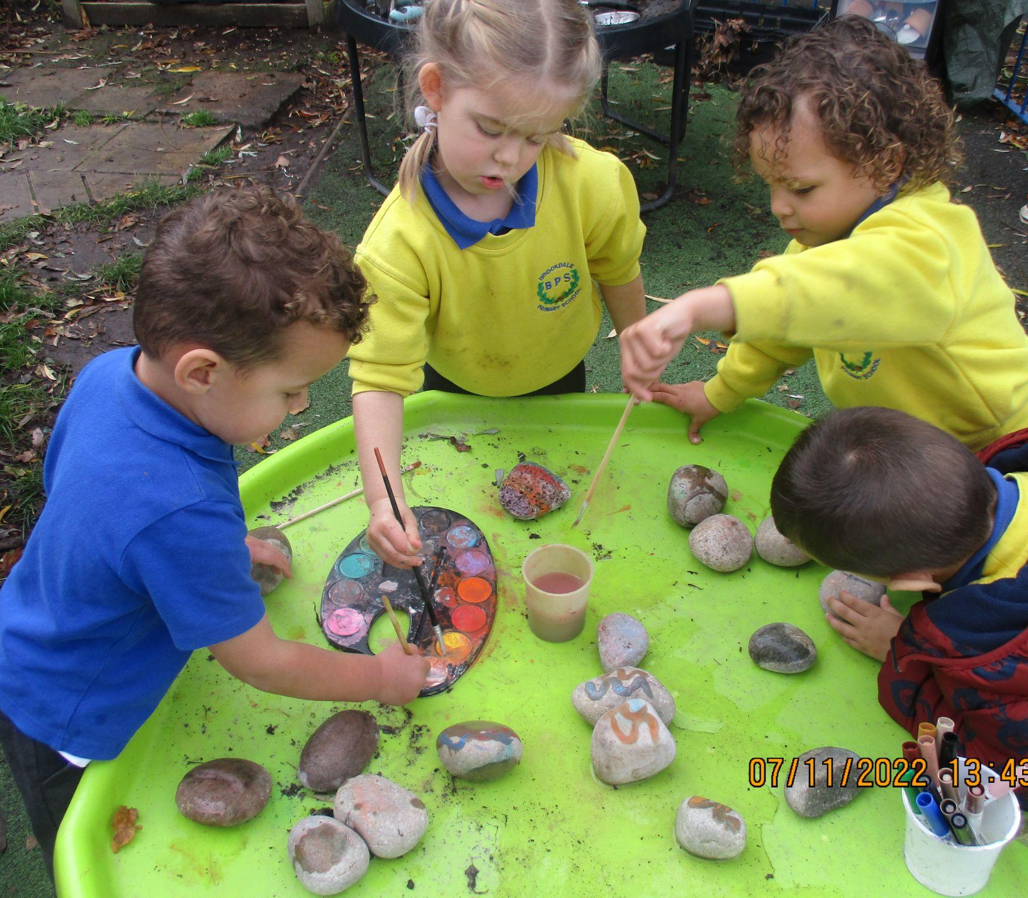

Health Promoting

We are a health-promoting setting and will provide opportunities for the children to learn about how to be healthy. We will provide children with a healthy snack each session and milk or water to drink. The children will engage in activities to learn how to be healthy as well as learning about oral hygiene. Some form of physical exercise will be done daily.

Water will be on offer throughout the day, should any child require it. Please ensure to inform us of any dietary requirements your child may have, including allergies.

Lunches – children may bring packed lunch or a hot meal can be ordered at the cost of £2 from Brookdale Bistro – these are payable via Parent pay.

Yoga

We strongly believe that physical skills are paramount to every child’s overall development. As part of our programme of physical activities, Yoga is a key aspect. Our Yoga activities will combine stretching exercises, different poses with deep breathing and meditation. It is intended to stretch and tone the muscles and to keep the spine and joints flexible. Research also suggests that the movements also massage the internal organs and glands. The breathing is diaphragmatic, which increases oxygen flow to the brain. Yoga instils good postural habits and creates a calm, focused, receptive mind.

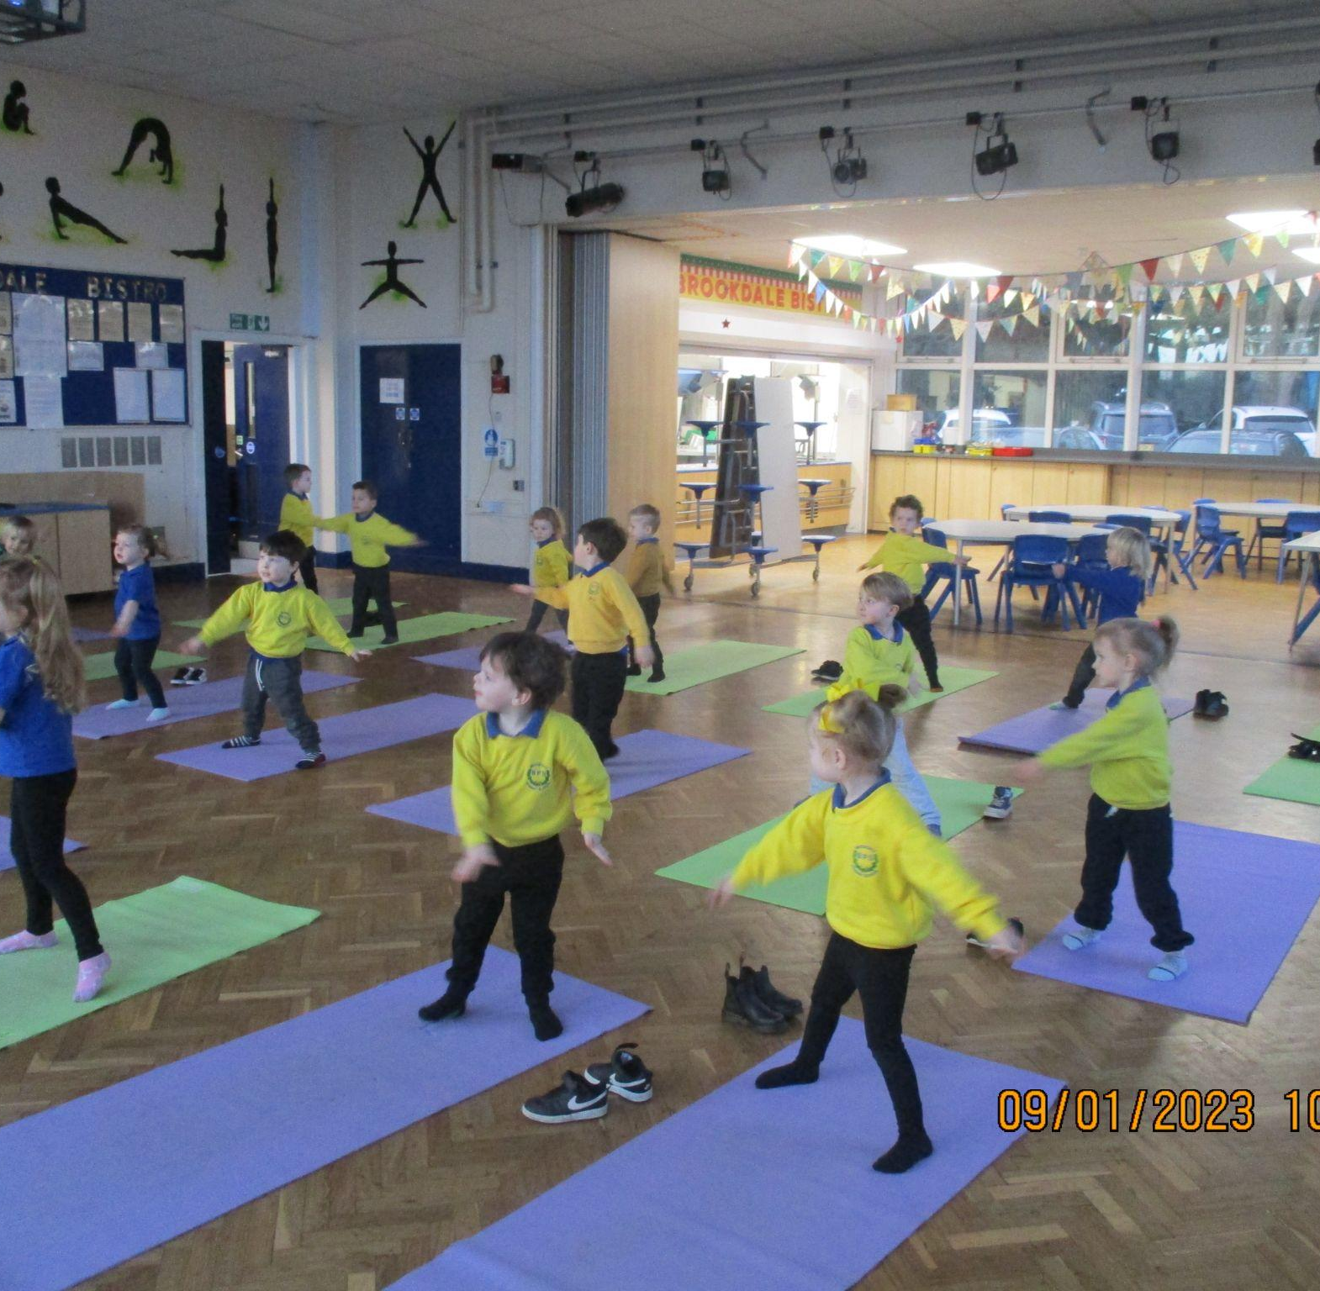

Parents as Partners

Parents are children’s first and most enduring educators. Working together with parents will result in a positive impact on a child’s development and learning. As a setting, we respect that all families are different, and they will all be welcomed and valued in our setting. We have a lot to learn from parents who will enable us to support their child’s development and learning. We aim to:

- Recognise and respect the role of the parent in their child’s learning and development
- Make all parents feel included and have a positive role in their child’s learning
- Be approachable, enabling parents to express their opinions and feelings
- Treat parents with respect and take their opinions seriously
- Value parents’ differing linguistic, cultural, and religious backgrounds
- Be a strong part of the local community.

To develop our partnership with parents, we will ask for all relevant information on their child to help us to get to know your child and their experiences so far to inform our planning and assessment. Parents are welcome to discuss their child with us at any time. Information is shared with parents via ClassDojo, letters, posters, and leaflets. We also offer information for parents regarding issues such as health, school choices etc. and will signpost parents to enable them to receive any necessary information and support.

Policies and Procedures

Our Early Years setting has a number of policies and procedures, which are continually updated to provide the best care for your child. Parents are welcome to view all policies at any time. They are available via the main school website; paper copies are available via the school office on request.

Once registered at Brookdale Early Years, you will be issued with a ‘Parent Pack’ which contains all the information you will need regarding our policies and necessary guidelines. We ask that you read this pack carefully to ensure the health and safety of all the children in the setting.

We hope this has provided you with the information you need and we look forward to meeting you and your child soon.

